Philadelphia University
Faculty of Information Technology
Department of Software Engineering
Examination Paper

Course Name: GUI (721423, 711471) Section: 1 Semester 2

Information for Candidates
- This examination paper contains questions 6 totaling 40 marks.
- The marks for parts of questions are shown in round brackets.

Advice to Candidates
1. You should attempt all questions
2. You should write your answers precisely, clearly and to the point.

I. Basic Notions
Objectives. The aim of the question in this part is to evaluate the required minimal student knowledge and skills. Answers in the pass category represent the minimum acceptable standard.

Question 1

- What is the aim of evaluation?
- Who should use evaluation?
- Describe two techniques for evaluation, highlighting their key points and the differences between them

II. Familiar Problems Solving
Objectives. The aim of the question in this part is to evaluate that the student has some basic knowledge of the key aspects of the lecture material and can attempt to solve familiar problems.

Question 2
Error message design is critically important. Poor error messages can mean that a user rejects rather than accepts a system.

A-Describe if the following GUIs have a problem or not? (5 marks)

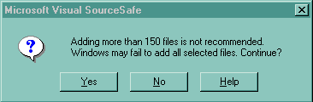

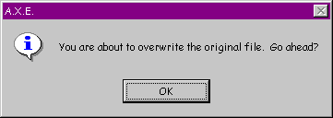

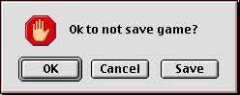

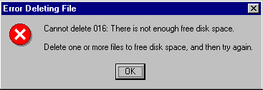

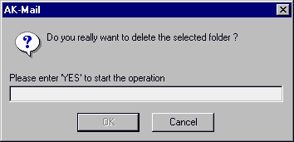

Question 3
List and explain Norman's four principles of good design.
List and explain the different types of expert reviews

Question 4

Describe five measurable human factors

What are the main needs that need to be addressed in interface guidelines?

Objectives. The aim of the question in this part is to evaluate that the student has some basic knowledge of the key aspects of the lecture material and can attempt to solve unfamiliar problems.

Question 5

Examine the following interface:

- Describe five things wrong with the interface on the left.

Question 6
The following screen-shot is taken from operating system. Briefly describe the main features that are you feel will support the user of this operating system.

. 

